Sonar qube:

[What is SonarQube and How it works? An Overview and Its Use Cases - DevOpsSchool.com](https://www.devopsschool.com/blog/what-is-sonarqube-and-how-it-works-an-overview-and-its-use-cases/)

**What is SonarQube?**

SonarQube is **a Code Quality Assurance tool that collects and analyzes source code, and provides reports for the code quality of your project**. It combines static and dynamic analysis tools and enables quality to be measured continually over time.

Static and dynamic analysis are two different approaches to software testing and quality assurance. Static analysis involves examining the source code and finding potential issues without actually running the program, while dynamic analysis involves executing the code and observing its behavior. SonarQube is a popular tool for static code analysis, but it doesn't directly perform dynamic analysis. To demonstrate both static and dynamic analysis, I'll provide a Java program with potential issues and then show how SonarQube can help identify and fix static code issues.

Download from [Download | SonarQube | Sonar (sonarsource.com)](https://www.sonarsource.com/products/sonarqube/downloads/)

Download from [SonarScanner (sonarsource.com)](https://docs.sonarsource.com/sonarqube/latest/analyzing-source-code/scanners/sonarscanner/) – download Sonar-scanner.

Unzip both and and store in C drive

Also install JDK 17

To start the sonarqube use:

C:\sonarqube-9.9.2.77730\bin\windows-x86-64\

Click on start sonar bat file.

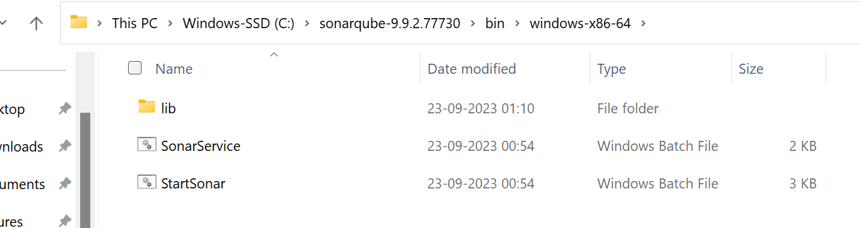

How to stop the server is ctrl+c and give yes to stop.

Again you can restart.

If sonar qube is not started there will be an error in picking the java files so follow the below link:

[SonarQube installation with 2 different Java JDKs version...!!! - YouTube](https://www.youtube.com/watch?v=Tekq6hqp1Nw&t=356s)

[Sonarqube install in your local windows machine - YouTube](https://www.youtube.com/watch?v=bnIvlnu_YL0&t=128s)

Once the server is fine it shows the below :

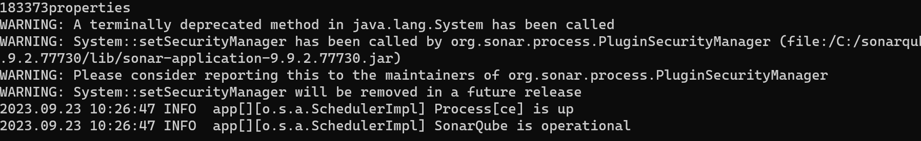

Now you can go the URL:

<http://localhost:9000/> on success it ask for the login details

give password and username as admin/admin

change the old password and keep your new password.

create a simple project: in eclipse

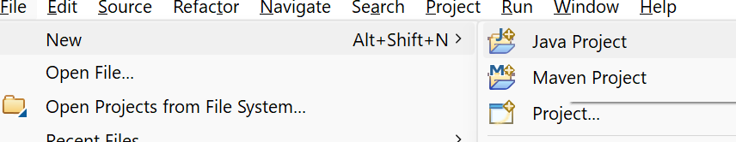

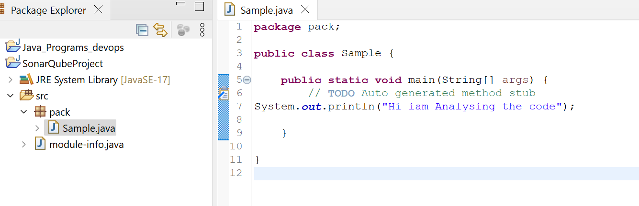

**package** pack;

**public** **class** Sample {

**public** **static** **void** main(String[] args) {

// **TODO** Auto-generated method stub

System.***out***.println("Hi iam Analysing the code");

}

}

After login in GUI

<http://localhost:9000/>

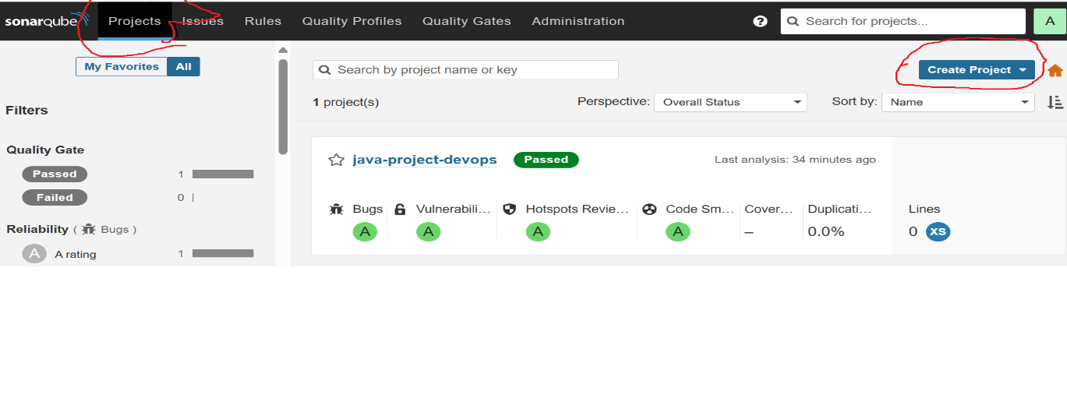

Click on Projects and click on create project.

Once you click on create project drop down menu will come and you can opt manually

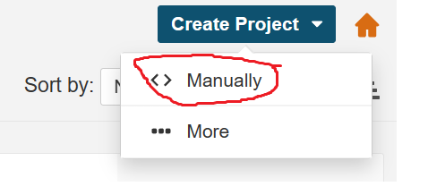

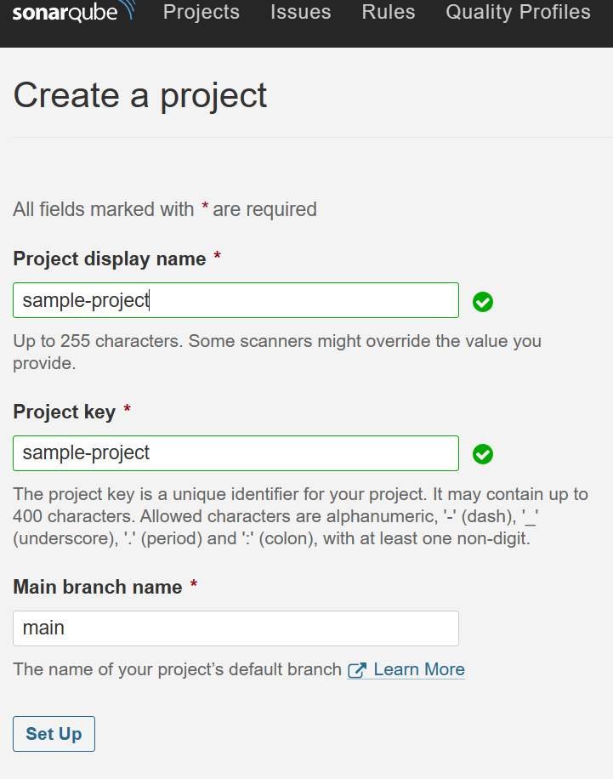

Give any project name and click on set up.

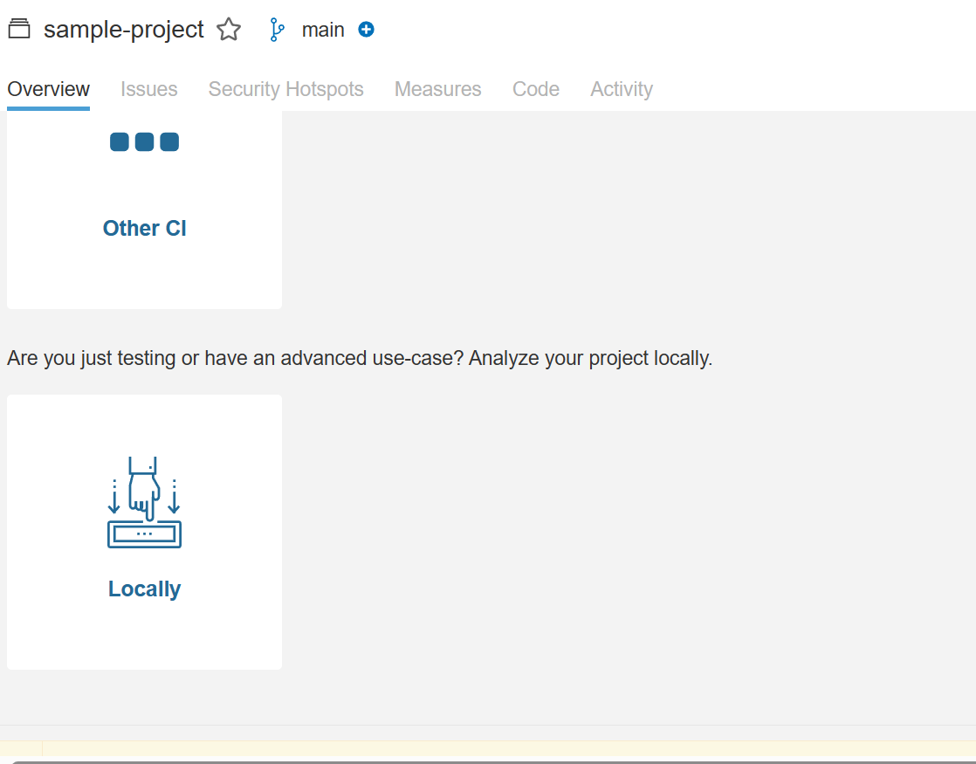

Click on locally.

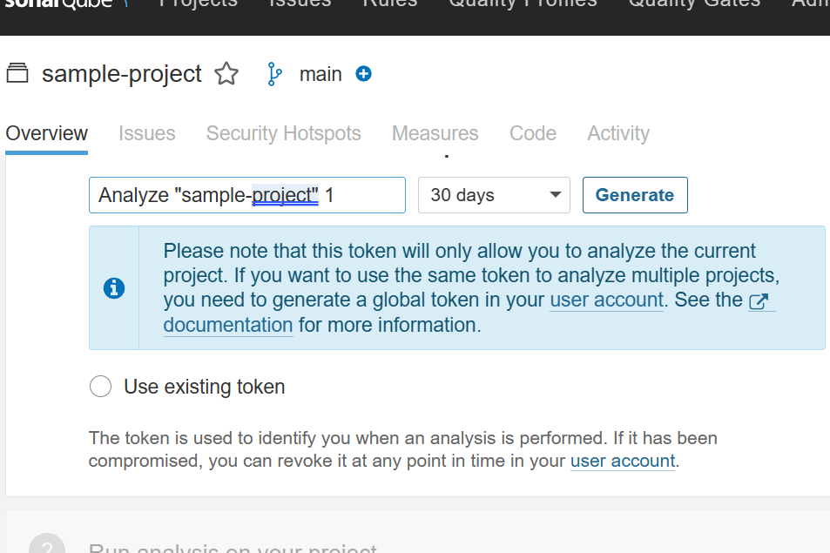

Click on generate Token:

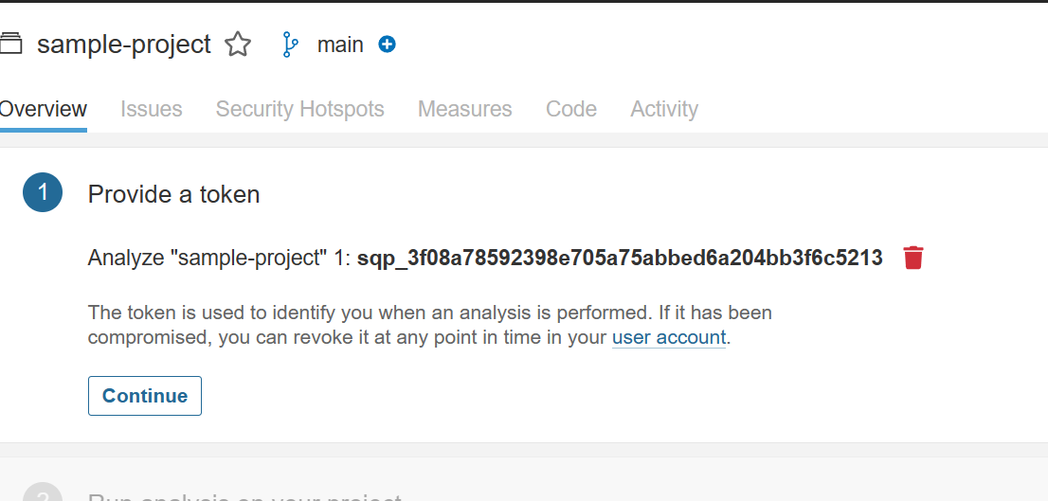

Click on continue.

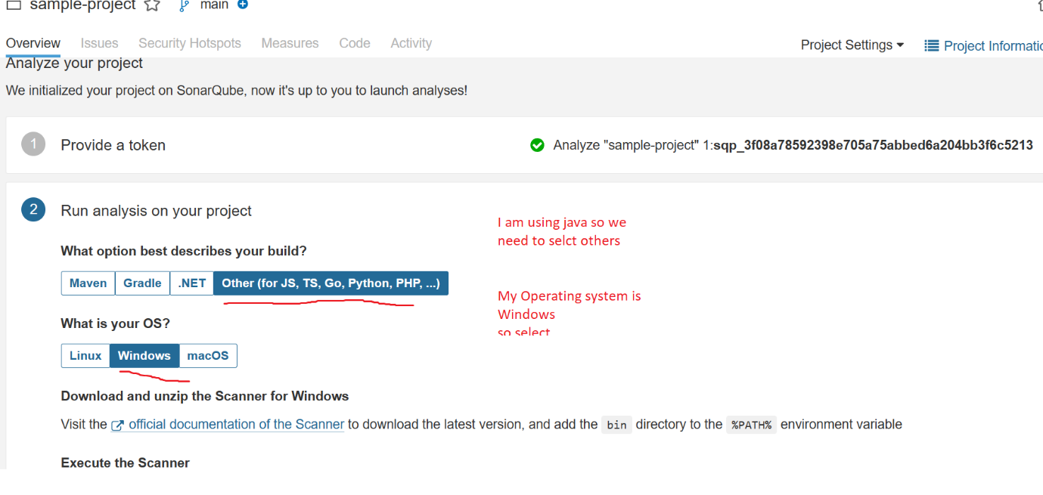

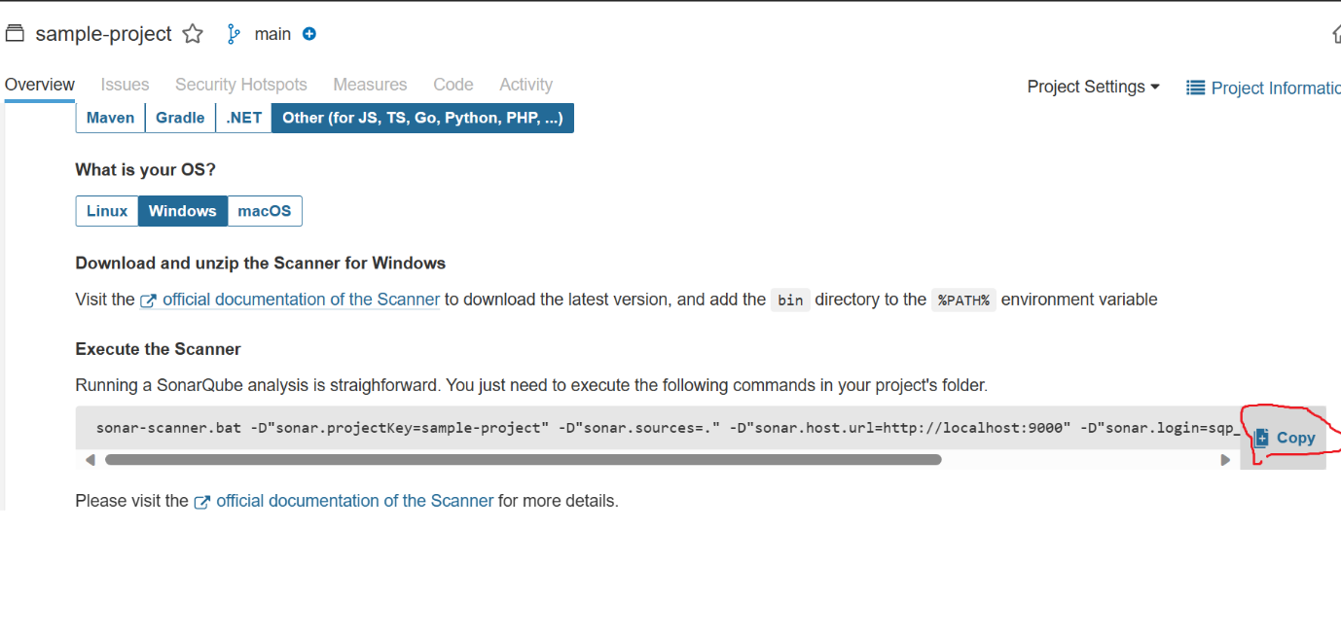

Copy the command:

sonar-scanner.bat -D"sonar.projectKey=sample-project" -D"sonar.sources=." -D"sonar.host.url=http://localhost:9000" -D"sonar.login=sqp_3f08a78592398e705a75abbed6a204bb3f6c5213"

Now go to the cmd prompt where out java project is available:

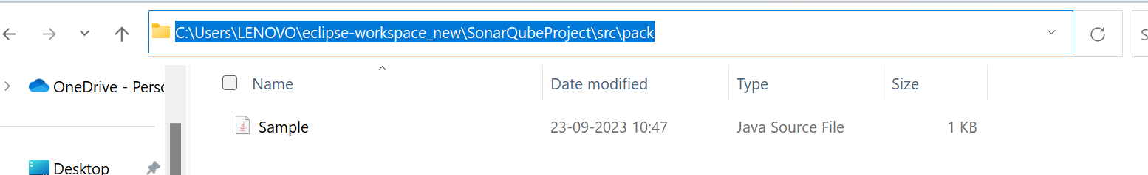

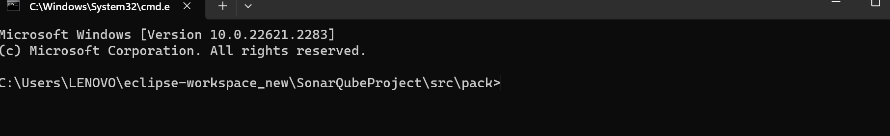

Now paste the command below which we have saved earlier.

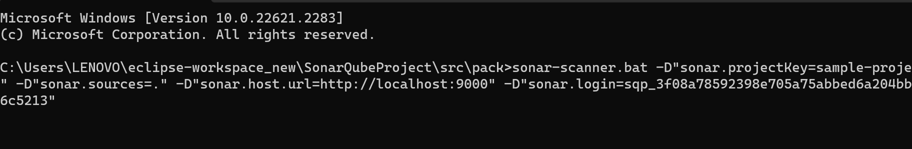

It will get failed

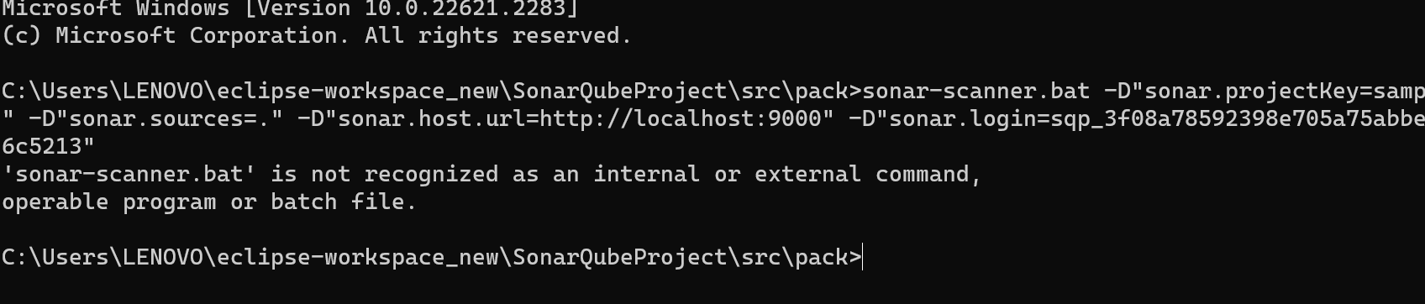

So give the complete path where out sonar -scanner.

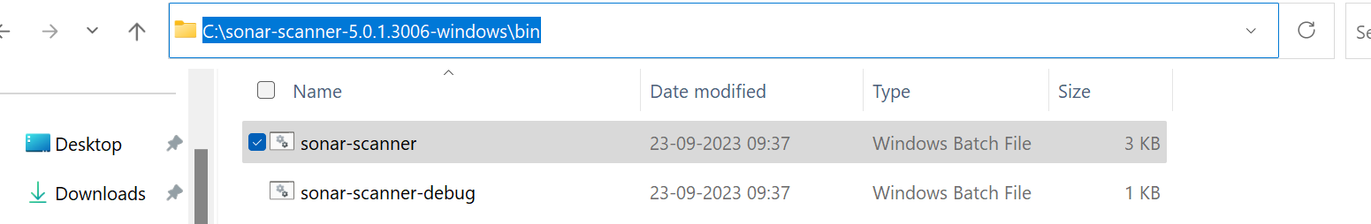

C:\sonar-scanner-5.0.1.3006-windows\bin\sonar-scanner.bat -D"sonar.projectKey=sample-project" -D"sonar.sources=." -D"sonar.host.url=http://localhost:9000" -D"sonar.login=sqp_3f08a78592398e705a75abbed6a204bb3f6c5213"

Complete path we have to give.

Be careful while add the path. Any space will give you the error.

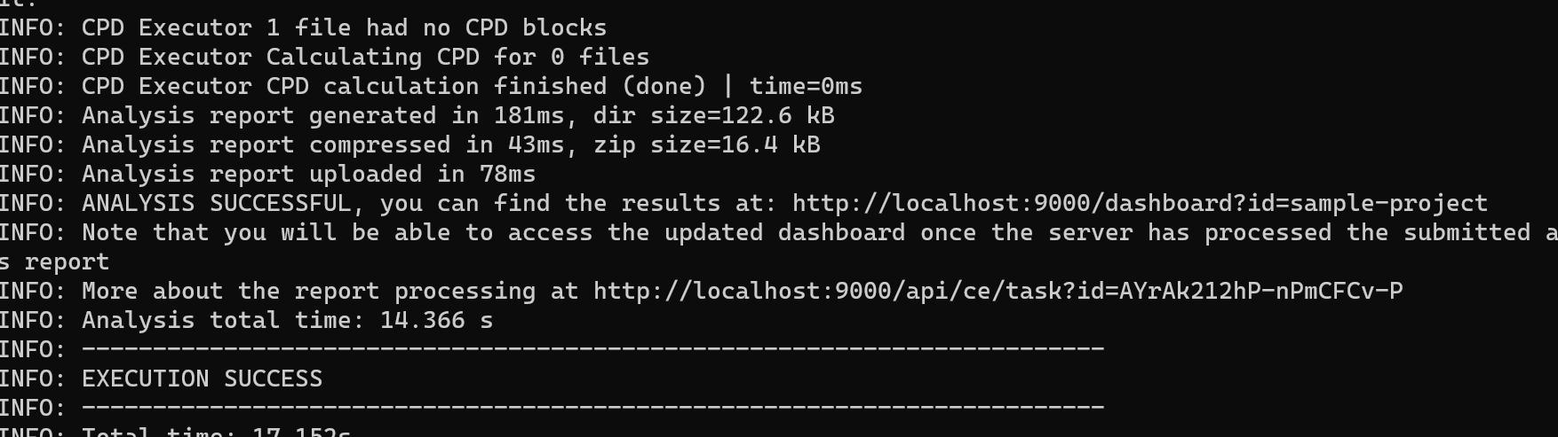

Now go to the sonar gui that is localhost:9000

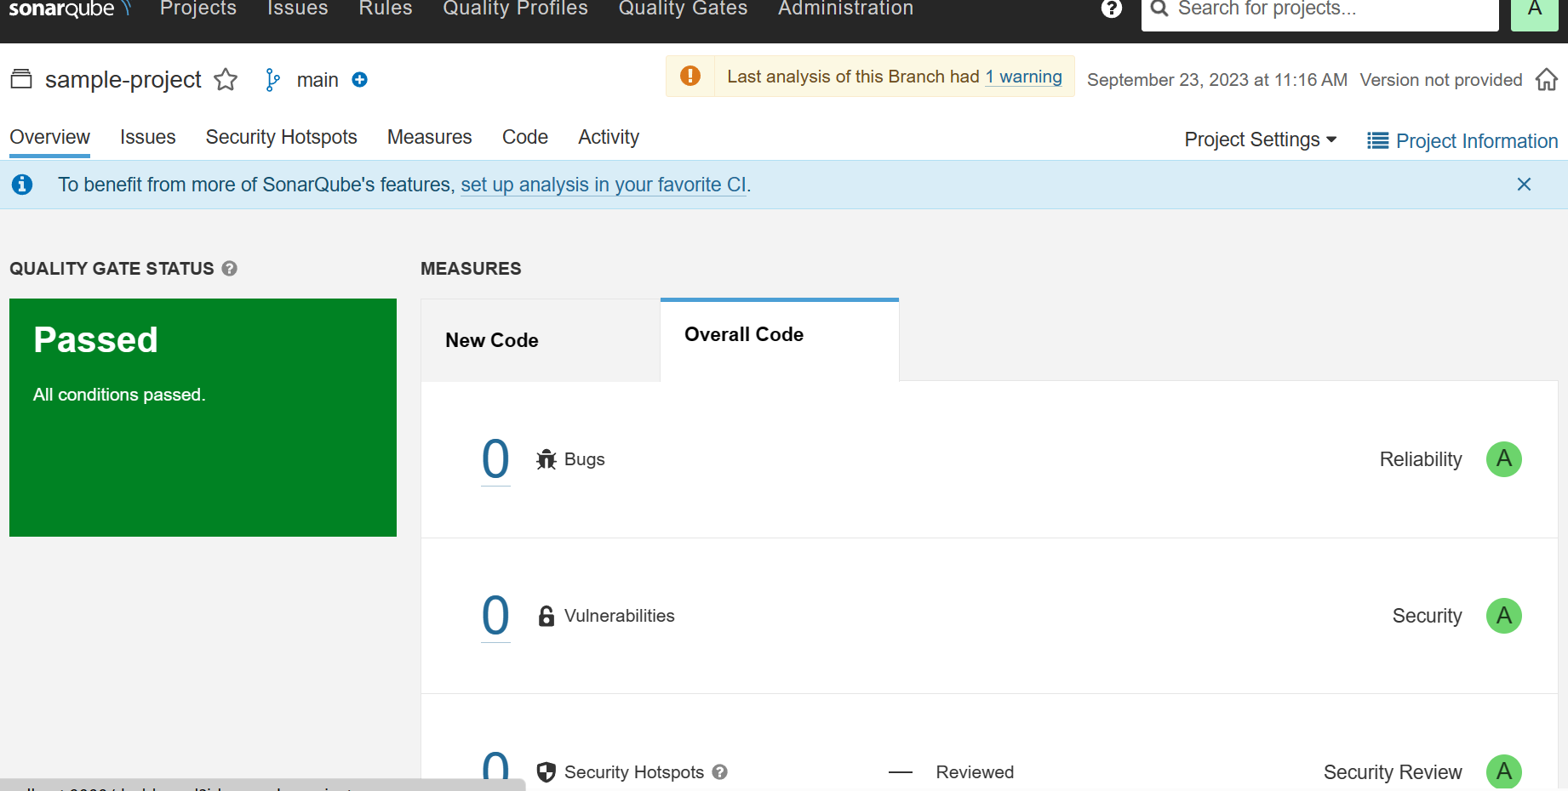

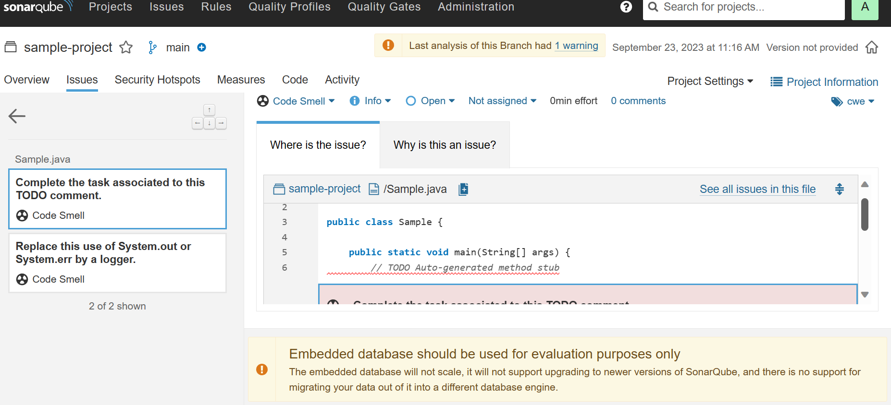

Go to each tab and it will give all the code details analysis.

**sonar scanner:**

C:\sonar-scanner-5.0.1.3006-windows\bin\sonar-scanner.bat -D"sonar.projectKey=java-project-devops" -D"sonar.sources=." -D"sonar.host.url=http://localhost:9000" -D"sonar.login=sqp_0c3a6334f8d62ce4e073fb11c3fb14f81f7b858a"

sonar-scanner -D"sonar.projectKey=java-project-devops" -D"sonar.sources=." -D"sonar.host.url=http://localhost:9000" -D"sonar.login=sqp_0c3a6334f8d62ce4e073fb11c3fb14f81f7b858a" -D"sonar.java.binaries=path/to/compiled/classes"

default user/password is admin---- change with your new password.